Confirmation 2024
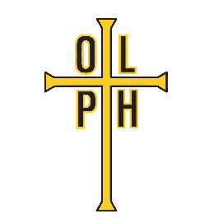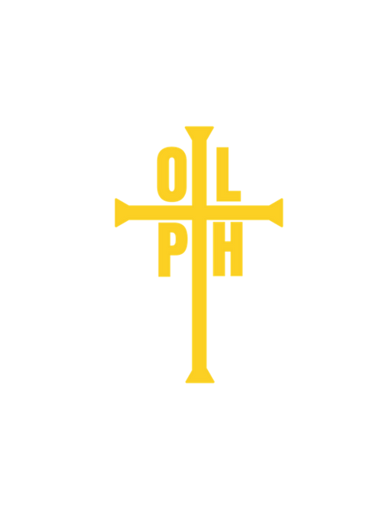
January | 11 | Confirmation Parent and Candidate Meeting 7:00 pm
February | 25 | Rite of Enrollment during 11:00 Mass
March | 28 | Holy Thursday
 | 29 | Good Friday
 | 30 | Easter Vigil
April | 27 | First Communion Retreat
May | 4 | First Communion
 | 19 | Confirmation Class – 5:00-6:30pm (Sponsor name due)
June | 2 | Confirmation Class – 5:00-6:30pm
June—  July |  | Confirmation Interviews – schedule will be created and distributed at Confirmation Class
August | 18 | Confirmation Class – 5:00-6:30pm (Confirmation name due)
 | 25 | Confirmation Class – 5:00-6:30pm
September | 1 | Labor Day Weekend – No Class
 | 8 | Confirmation Class – 5:00-6:30pm
 | 15 | Confirmation Class – 5:00-6:30pm
 | 22 | Retreat & Practice – 9:00am-5:00pm (includes Mass)
 | 29 | Retreat Planning & Catch-up work – 5:00-6:30pm
October | 6 | Parent Retreat – following 11:00 am Mass 12:00-4:00pm
 | 11-13 | OLPH Fair
 | 21 | Confirmation Ceremony 7:00pm with Archbishop Hughes

Dates and times are subject to change.
Please stay updated through emails and class announcements.

